Task 1 — Setup a Virtual Machine Using Ubuntu Image

Objective

Create and configure an Ubuntu-based virtual machine to serve as the environment for Docker and DevOps activities.
Since you're working with AWS EC2, we'll create an Ubuntu EC2 instance.

Architecture
Your Laptop
|
| SSH
v
+-------------------------+
| AWS EC2 |
| |
| Ubuntu Server |
| |
| Docker |
| | |
| +-- Nginx |
| +-- Tomcat |
| +-- Ubuntu |
| +-- Jenkins |
| +-- SonarQube |
+-------------------------+

Step 1. Open EC2
Go to AWS Console → EC2 → Instances → Launch instances

Step 2. Configure the instance
Use approximately these settings:

Name
docker-server

Application and OS Image
Select:
Ubuntu
Choose an Ubuntu Server LTS AMI.
For example:
Ubuntu Server 24.04 LTS

Instance type
For this practical, use:
t3.small
If your account has another suitable instance available, you can use that.
Jenkins + SonarQube together can consume significant RAM, so avoid a very small instance if possible.

Step 3. Key pair
Select your existing EC2 key pair, or create a new one.
Example:
docker-server-key
Download the .pem file if you create a new key.
Do not lose the key.

Step 4. Network settings
For now, allow:
SSH TCP 22
Source: My IP
For Nginx, we'll eventually need:
TCP 81
For Jenkins, eventually:
TCP 8080

Step 5. Storage
Use something like:
20 GB
or more if available.
Docker images such as Jenkins and SonarQube are relatively large.

Step 6. Launch
Click:
Launch instance
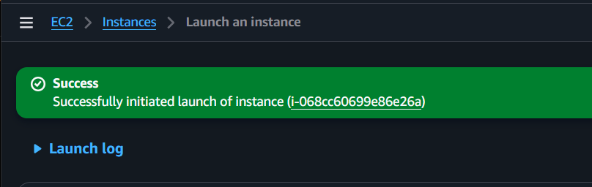

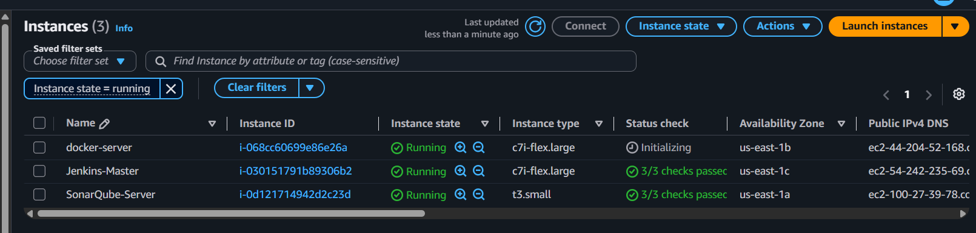
Wait until the instance shows:
Instance state: Running
and:
Status check: 3/3 checks passed
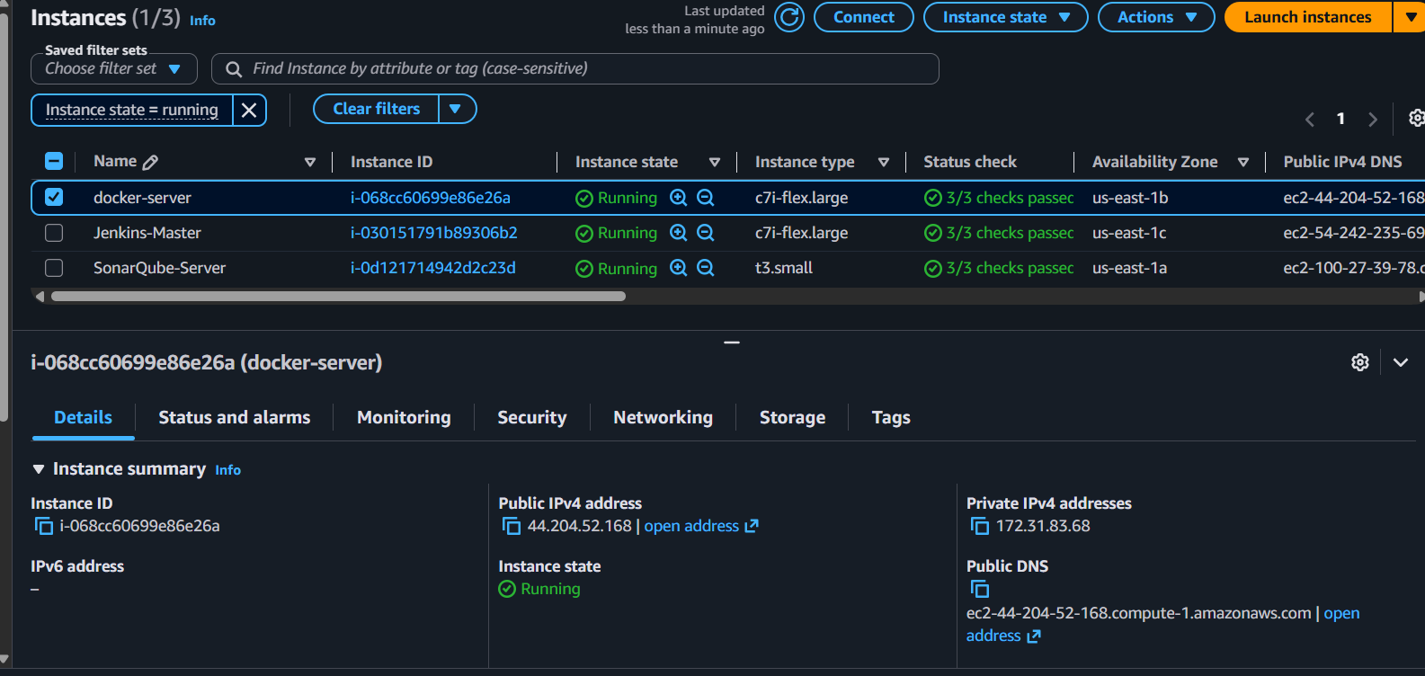

Step 7. Connect to Ubuntu
From your terminal, use the SSH command AWS provides.
It will look similar to:
ssh -i "docker-server-key.pem" ubuntu@<PUBLIC-IP>
For example:
ssh -i "docker-server-key.pem" ubuntu@54.xx.xx.xx
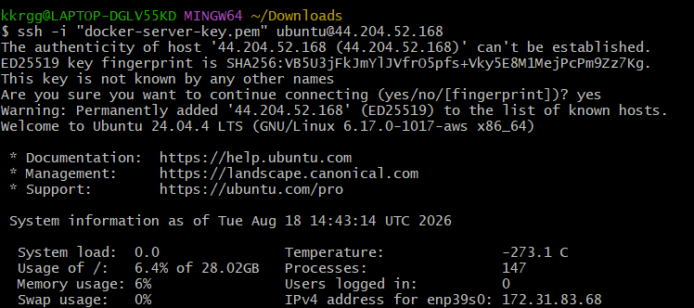
The Ubuntu default username is:
Ubuntu
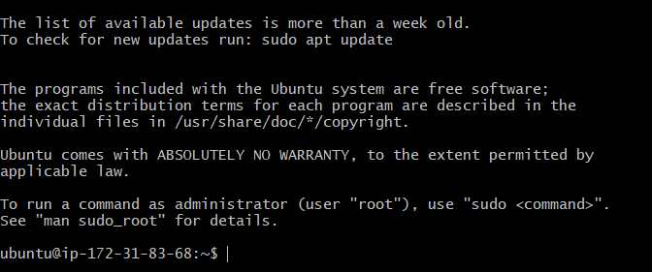

Step 8. Verify the VM
After connecting, run:
cat /etc/os-release
You should see something similar to:
NAME="Ubuntu"
VERSION="24.04 LTS"
Then:
uname -a
And:
whoami
Expected:
ubuntu

Task 1 Completion Check
Run these commands:
cat /etc/os-release
whoami
uname -a
If you get:
Ubuntu
ubuntu
Linux ...
then Task 1 is completed.
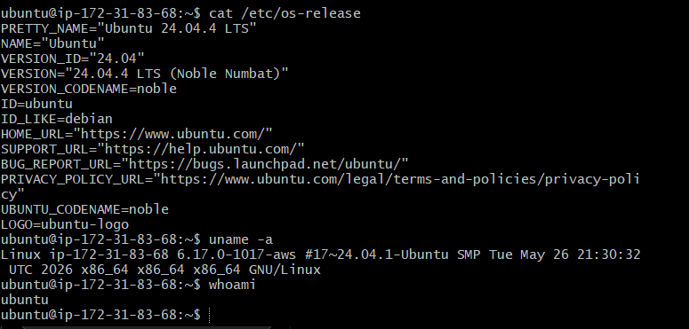

Outcome
Ubuntu VM — A functional Ubuntu virtual machine was successfully created and configured.

Task 2 — Install Docker on EC2

Objective

Install and configure Docker on the EC2 instance so that containers and Docker images can be managed.
Now we'll install Docker on this Ubuntu server.

Step 2.1 — Update packages
Run:
sudo apt update
Wait for it to complete.
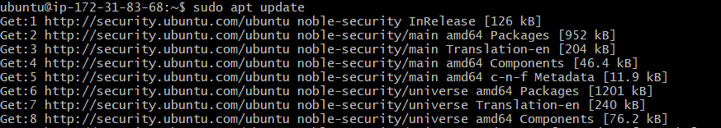
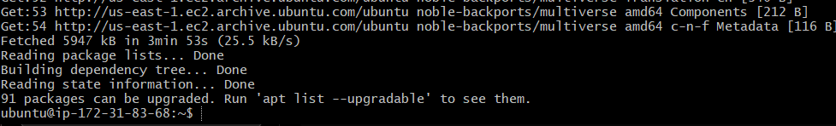
Then run:
sudo apt upgrade -y
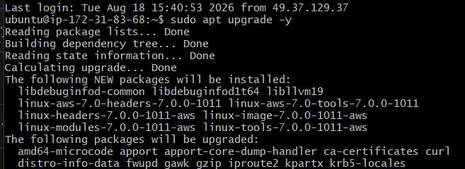

Step 2.2 — Install Docker
Ubuntu provides the Docker package through its repository. Run:
sudo apt install docker.io -y
This installs Docker and its required dependencies.
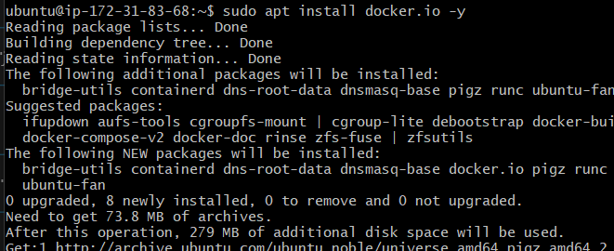

Step 2.3 — Check Docker version
Run:
docker --version
You should get something similar to:
Docker version 28.x.x, build ...
The exact version may be different.

Step 2.4 — Start Docker
Run:
sudo systemctl start docker
Then enable Docker so it automatically starts after an EC2 reboot:
sudo systemctl enable docker

Step 2.5 — Check Docker service
Run:
sudo systemctl status docker
You should see:
Active: active (running)
Press:
q
to exit the status screen.
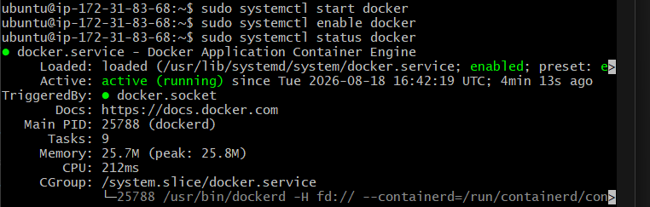

Step 2.6 — Allow the ubuntu user to run Docker
Normally Docker requires sudo.
sudo docker ps
Run:
sudo usermod -aG docker ubuntu
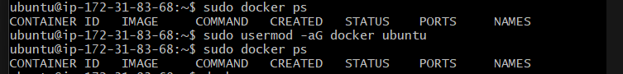
If you see:
CONTAINER ID IMAGE COMMAND CREATED STATUS PORTS NAMES
with no containers listed, that's perfectly fine.
It means Docker is working.

Step 2.7 — Test Docker
Run the sudo docker run hello-world command:
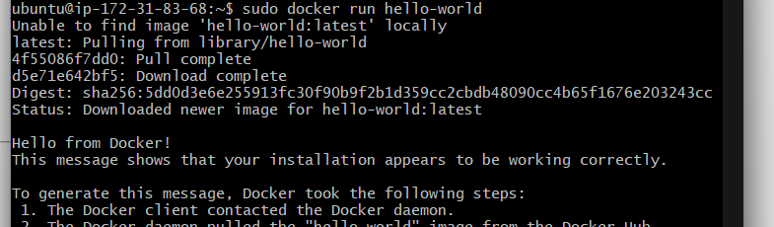
Outcome
Docker on EC2 — Docker was successfully installed and made ready for container operations.
Task 3: Pull 5 Docker images: Nginx, Apache Tomcat, Ubuntu, Jenkins, SonarQube
Objective:
To download and store the required Docker images: Nginx, Apache Tomcat, Ubuntu, Jenkins, and SonarQube.
Outcome:
All five Docker images were successfully pulled and stored locally.
Definition: Pulling a Docker image means downloading the image from Docker Hub
to your EC2 machine.

Step 1: pull nginx with command sudo docker pull nginx
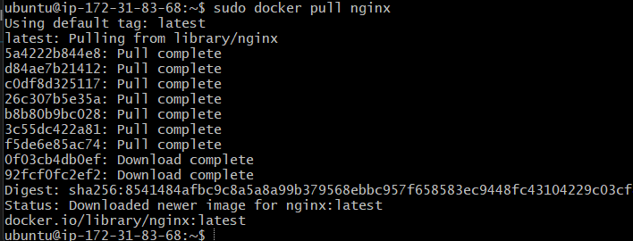
Step 2: pull Apache tomcat with command sudo docker pull tomcat
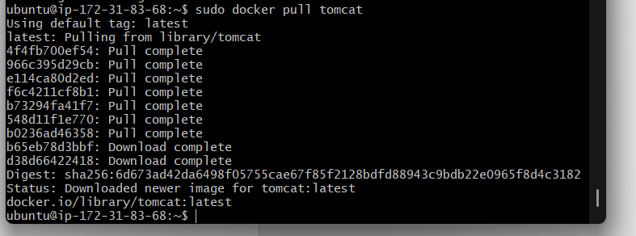
Step 3: pull Ubuntu with command sudo docker pull ubuntu
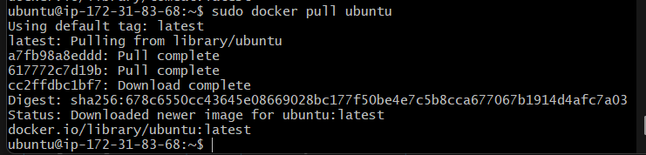
Step 4: pull Jenkins with command sudo docker pull Jenkins/Jenkins
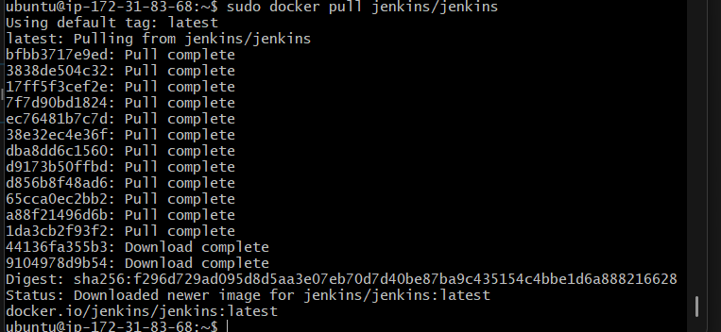
Step 5: pull SonarQube with command sudo docker pull sonarqube
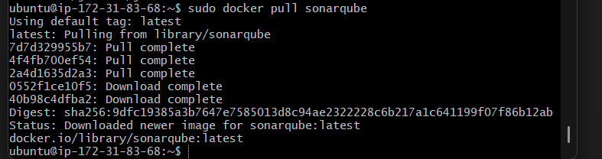

Verify all 5 images
sudo docker images
You should see images similar to:
nginx
tomcat
ubuntu
jenkins/jenkins
sonarqube
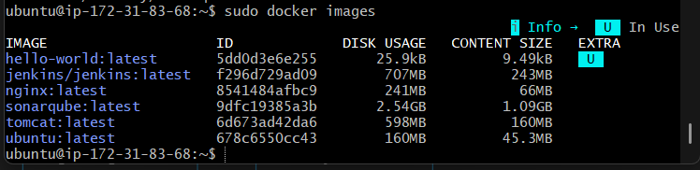

Task 4 — Run Nginx Container on Port 81
Objective:
To run an Nginx container and make its web service accessible through port 81.
Outcome:
The Nginx container was successfully started and accessed through port 81.

1. Pull the Nginx image
docker pull nginx

2. Run the Nginx container
docker run -d --name nginx-container -p 81:80 nginx
Here:
- -d → Runs the container in the background
- --name nginx-container → Names the container
- -p 81:80 → Maps EC2 host port 81 → container port 80
- nginx → Docker image

3. Verify the container
docker ps
You should see:
CONTAINER ID IMAGE PORTS
xxxxx nginx 0.0.0.0:81->80/tcp

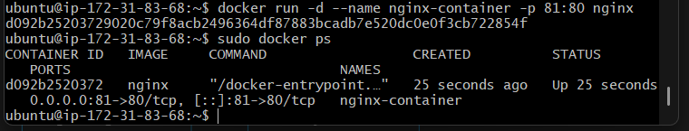

4. Test Nginx
From the EC2 server:
curl http://localhost:81
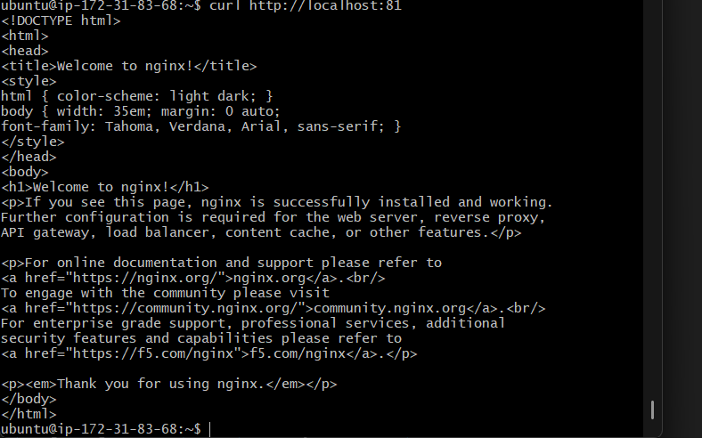
You should get the Nginx welcome page HTML.
From your browser:
http://<EC2-PUBLIC-IP>:81

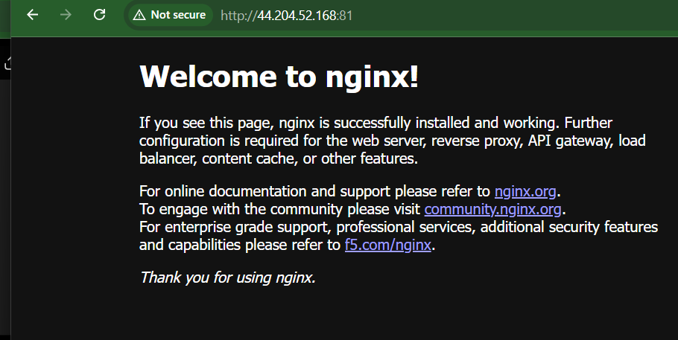

Task 5 — Delete Apache Tomcat Image from local
Objective:
To practice Docker image management by removing the unused Apache Tomcat image from the local system.
Outcome:
The Apache Tomcat image was successfully removed from the local Docker environment.

1. Check the Tomcat image
docker images
You should see something like:
REPOSITORY TAG IMAGE ID
tomcat latest xxxxx
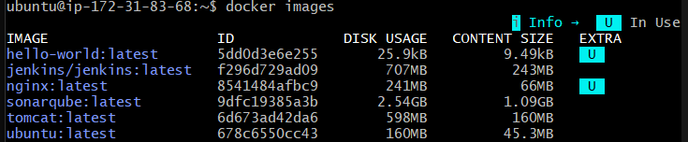

2. Delete the Tomcat image
docker rmi tomcat

3. Verify
docker images
The tomcat image should no longer appear.
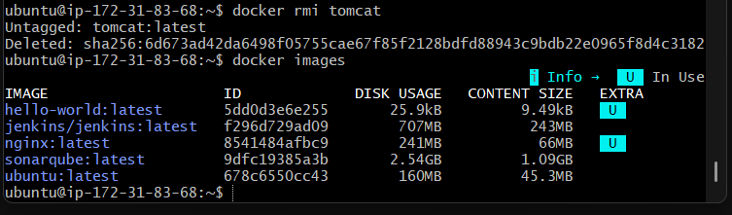

If Docker says the image is being used
First check containers:
docker ps -a
If a Tomcat container exists and you don't need it:
docker rm -f <container_id>
Then delete the image:
docker rmi tomcat

Task 6 — Inspect Jenkins and SonarQube Images
Objective:
To inspect the configuration and metadata of the Jenkins and SonarQube Docker images using Docker commands.
Outcome:
The Jenkins and SonarQube images were successfully inspected and their image details were displayed.
Use docker inspect to inspect the image details.

1. Inspect Jenkins image
docker inspect jenkins/Jenkins
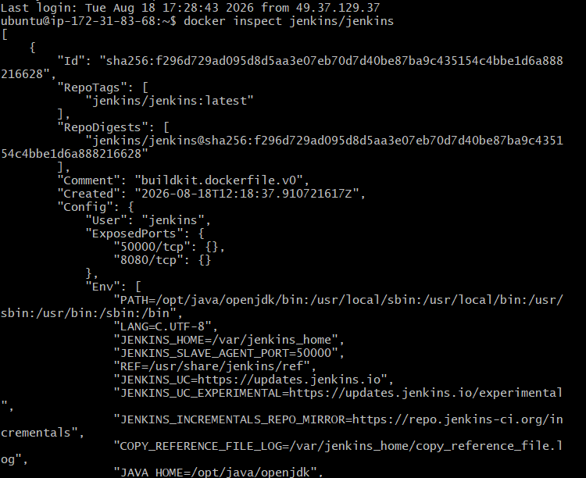

2. Inspect SonarQube image
docker inspect sonarqube
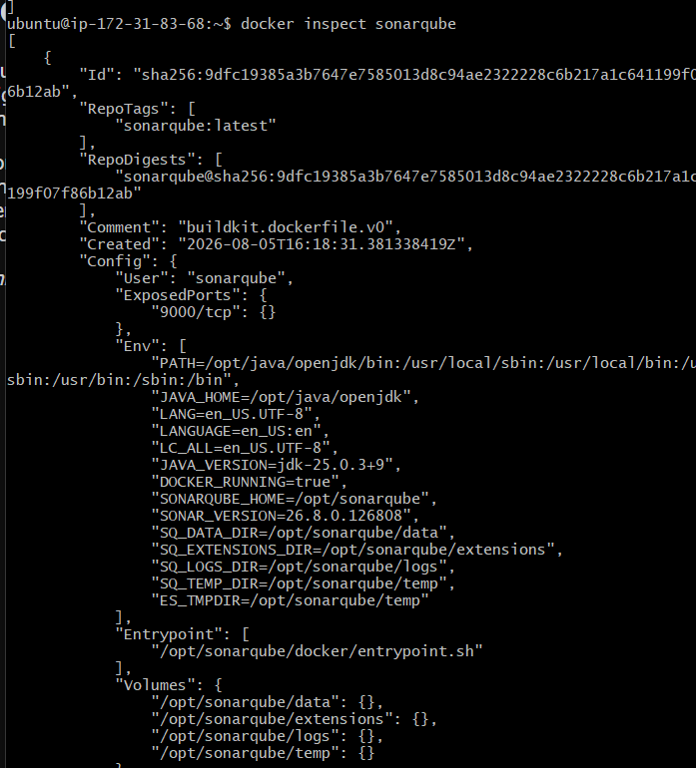
This displays detailed information such as:
- Image ID
- Creation date
- Architecture
- OS
- Environment variables
- Exposed ports
- Volumes
- Entrypoint
- CMD
- Docker layers
To see basic details :
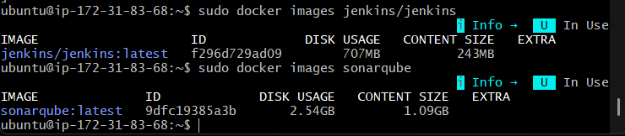

Task 7 — Run Jenkins Container and Execute a Sample Job
Objective:
To deploy Jenkins as a Docker container and verify its functionality by executing a sample Jenkins job.
Outcome:
The Jenkins container was successfully started, and the sample job executed successfully with a SUCCESS status.

1. Run Jenkins container
docker run -d \
--name jenkins-container \
-p 8080:8080 \
-p 50000:50000 \
jenkins/jenkins
- 8080 → Jenkins web UI
- 50000 → Jenkins agent communication
- --name jenkins-container → Container name
- 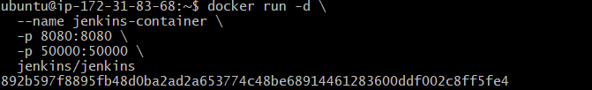

2. Check the container
docker ps
You should see:
jenkins/jenkins 0.0.0.0:8080->8080/tcp
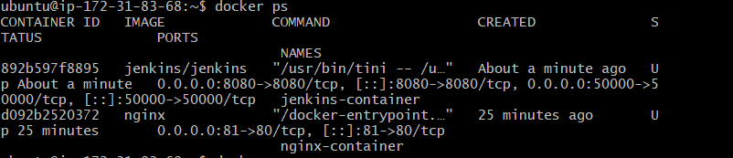

3. Get the initial Jenkins password
Run:
docker exec jenkins-container \
cat /var/jenkins_home/secrets/initialAdminPassword
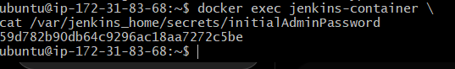
Copy the password.

4. Open Jenkins
If this is running on EC2, add TCP 8080 to the EC2 Security Group.
Then open:
http://<EC2-PUBLIC-IP>:8080
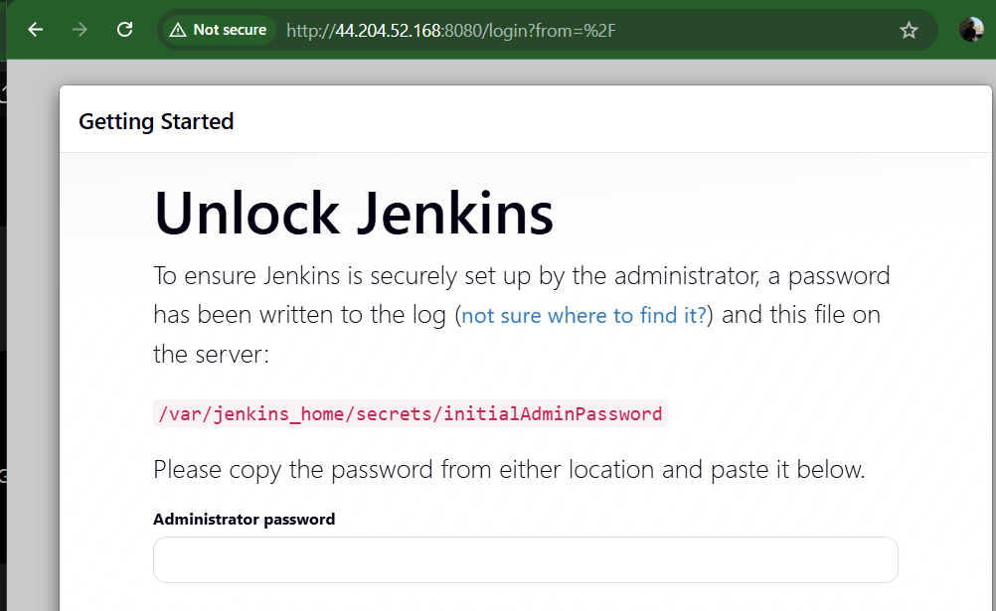
Enter the initial password and complete the Jenkins setup.
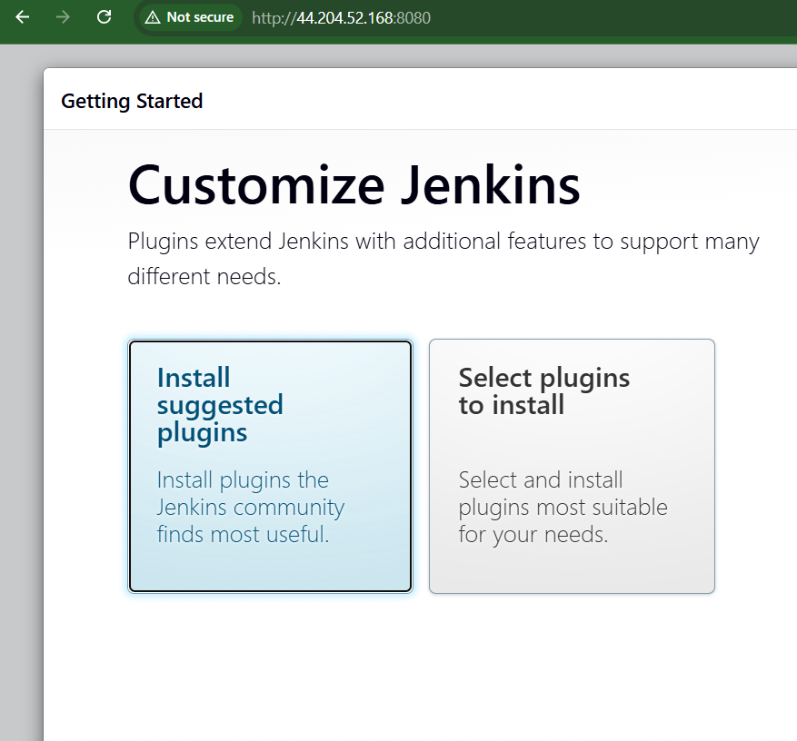

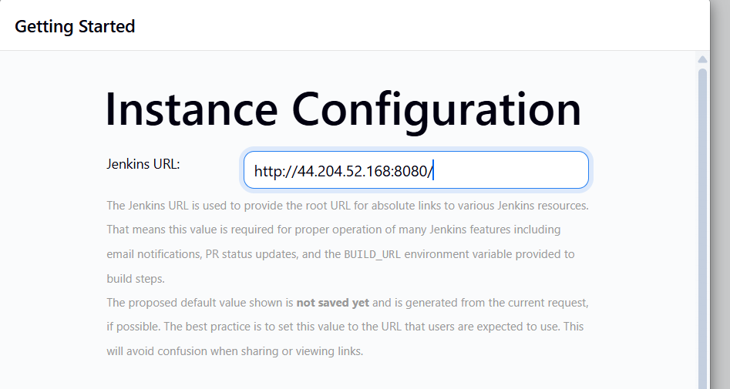
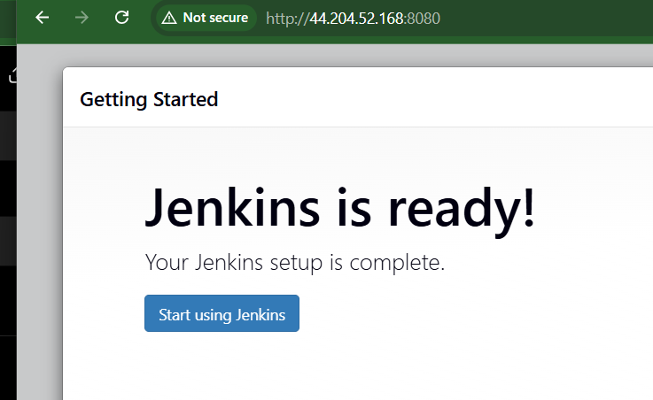

5. Create a sample job
In Jenkins:
Dashboard → New Item
Enter:
sample-job
Select:
Freestyle project → OK
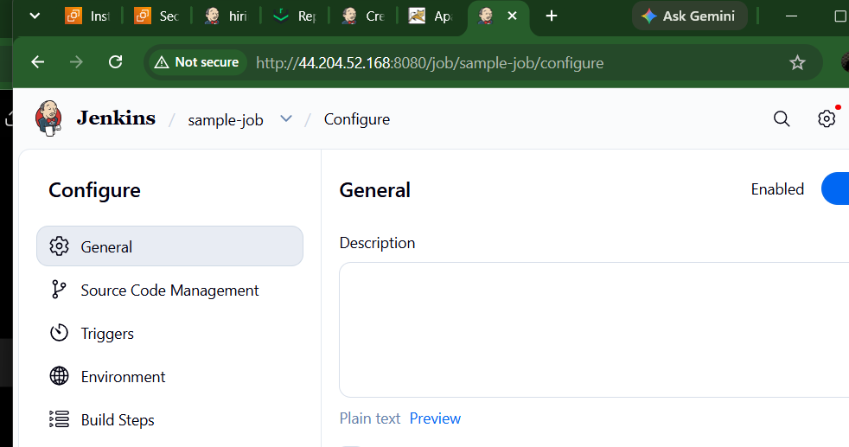
Go to:
Build Steps → Add build step → Execute shell
Enter:
echo "Hello from Jenkins Docker Container"
echo "Build Number: $BUILD_NUMBER"
echo "Job Name: $JOB_NAME"
echo "Workspace: $WORKSPACE"
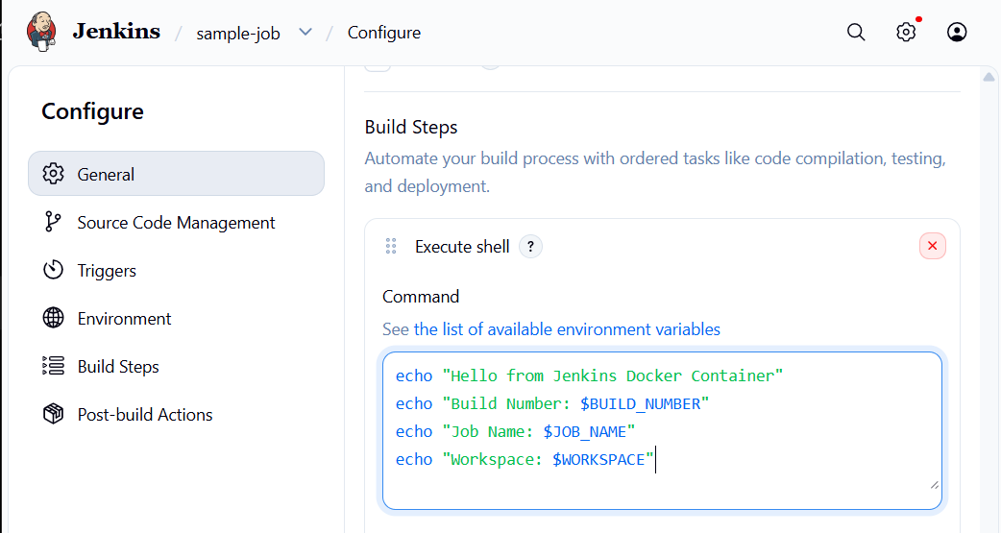
Click:
Save → Build Now
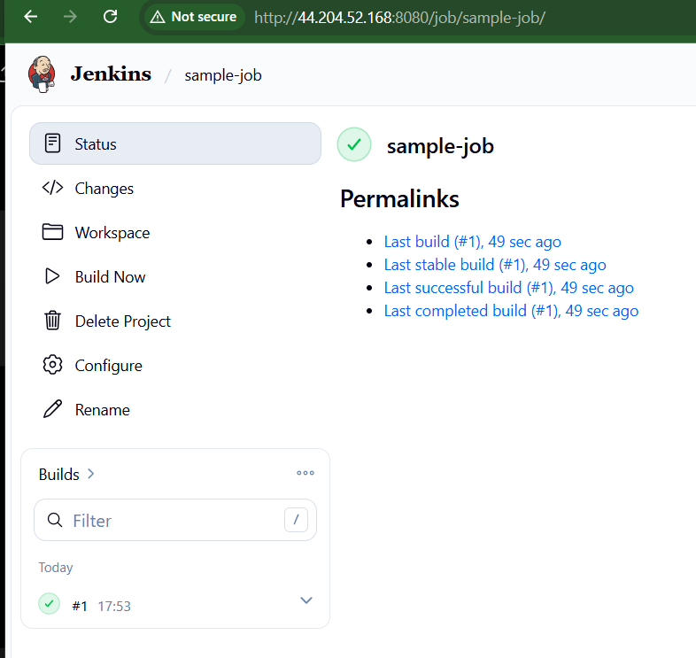

6. Check the result
Go to:
sample-job → Build #1 → Console Output
You should see something similar to:
Hello from Jenkins Docker Container
Build Number: 1
Job Name: sample-job
Workspace: /var/jenkins_home/workspace/sample-job

Finished: SUCCESS
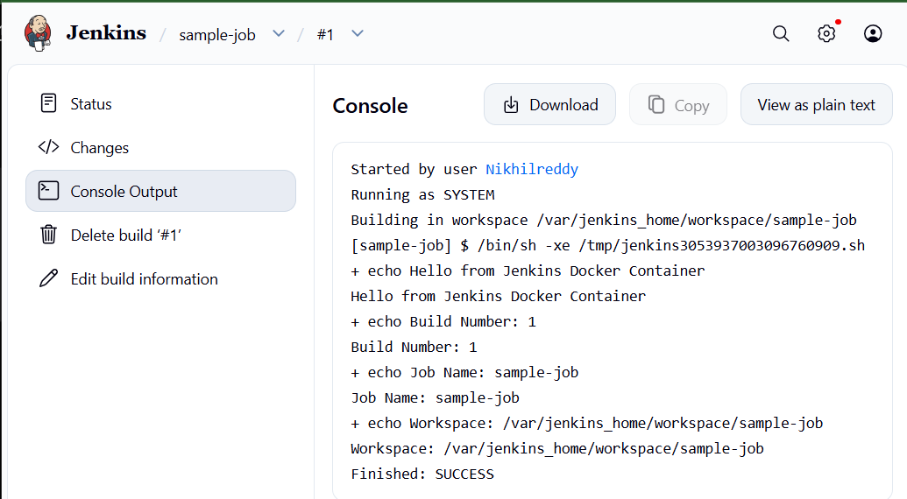

Done — Jenkins container is running and a sample job has been executed.

